**DAY 6 LAB**

**1.Write a program to implement Circular Queue with insertion and deletion operations**.

#include <stdio.h>

#define SIZE 5

int items[SIZE];

int front = -1, rear = -1;

int isFull() {

if ((front == rear + 1) || (front == 0 && rear == SIZE - 1)) {

return 1;

}

return 0;

}

int isEmpty() {

if (front == -1) {

return 1;

}

return 0;

}

void enQueue(int element) {

if (isFull()) {

printf("\nQueue is full!");

} else {

if (front == -1) {

front = 0;

}

rear = (rear + 1) % SIZE;

items[rear] = element;

printf("\nInserted element: %d", element);

}

}

void deQueue() {

int element;

if (isEmpty()) {

printf("\nQueue is empty!");

} else {

element = items[front];

if (front == rear) {

front = -1;

rear = -1;

} else {

front = (front + 1) % SIZE;

}

printf("\nDeleted element: %d", element);

}

}

void display() {

int i;

if (isEmpty()) {

printf("\nQueue is empty!");

} else {

printf("\nFront: %d", front);

printf("\nItems: ");

for (i = front; i != rear; i = (i + 1) % SIZE) {

printf("%d ", items[i]);

}

printf("%d", items[i]);

printf("\nRear: %d", rear);

}

}

int main() {

enQueue(1);

enQueue(2);

enQueue(3);

enQueue(4);

enQueue(5);

display();

deQueue();

deQueue();

display();

enQueue(6);

enQueue(7);

display();

return 0;

}

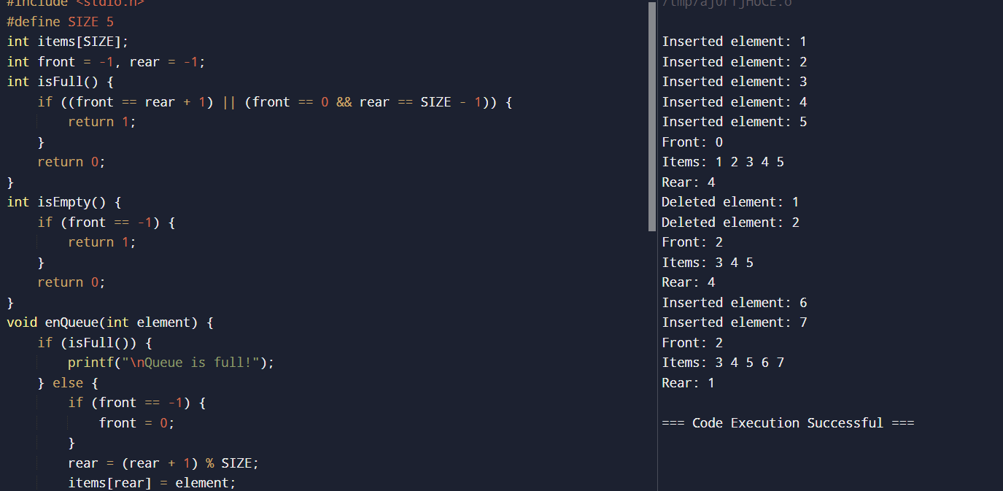

**2.Write a program to implement Double Ended Queue with insertion and deletion operations.**

#include <stdio.h>

#include <stdlib.h>

#define MAX_SIZE 5

int deque[MAX_SIZE];

int front = -1, rear = -1;

void insertFront(int item) {

if ((front == 0 && rear == MAX_SIZE - 1) || (front == rear + 1)) {

printf("Queue Overflow\n");

return;

}

if (front == -1) {

front = 0;

rear = 0;

} else if (front == 0) {

front = MAX_SIZE - 1;

} else {

front = front - 1;

}

deque[front] = item;

printf("%d inserted at front\n", item);

}

void insertRear(int item) {

if ((front == 0 && rear == MAX_SIZE - 1) || (front == rear + 1)) {

printf("Queue Overflow\n");

return;

}

if (rear == -1) {

front = 0;

rear = 0;

} else if (rear == MAX_SIZE - 1) {

rear = 0;

} else {

rear = rear + 1;

}

deque[rear] = item;

printf("%d inserted at rear\n", item);

}

void deleteFront() {

if (front == -1) {

printf("Queue Underflow\n");

return;

}

printf("%d deleted from front\n", deque[front]);

if (front == rear) {

front = -1;

rear = -1;

} else if (front == MAX_SIZE - 1) {

front = 0;

} else {

front = front + 1;

}

}

void deleteRear() {

if (rear == -1) {

printf("Queue Underflow\n");

return;

}

printf("%d deleted from rear\n", deque[rear]);

if (front == rear) {

front = -1;

rear = -1;

} else if (rear == 0) {

rear = MAX_SIZE - 1;

} else {

rear = rear - 1;

}

}

void display() {

int i;

if (front == -1) {

printf("Queue is empty\n");

return;

}

printf("Elements in the Queue are: ");

if (front <= rear) {

for (i = front; i <= rear; i++) {

printf("%d ", deque[i]);

}

} else {

for (i = front; i < MAX_SIZE; i++) {

printf("%d ", deque[i]);

}

for (i = 0; i <= rear; i++) {

printf("%d ", deque[i]);

}

}

printf("\n");

}

int main() {

insertFront(1);

insertRear(2);

insertRear(3);

display();

deleteFront();

display();

insertFront(4);

insertRear(5);

display();

deleteRear();

display();

return 0;

}

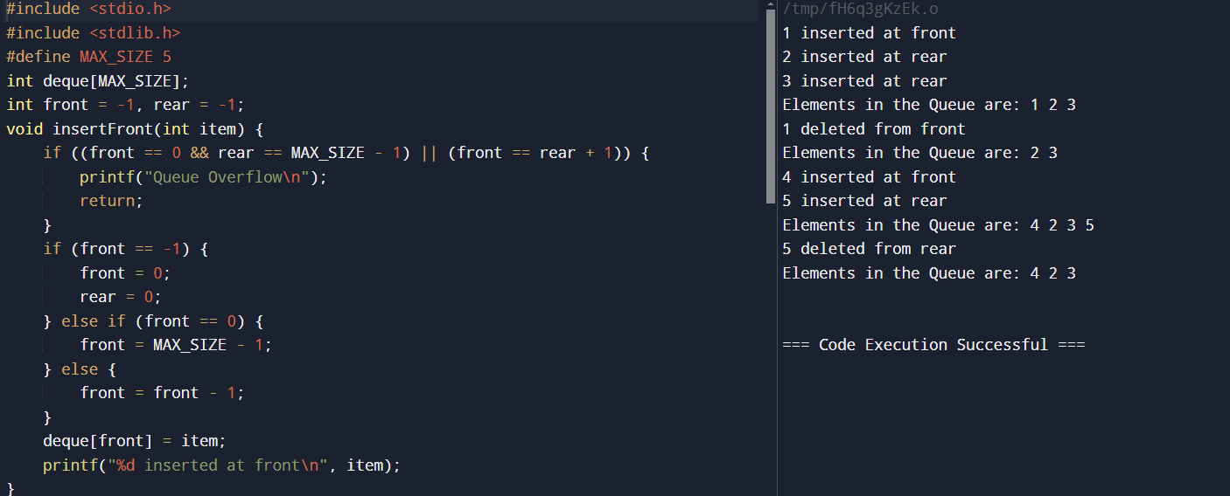

**3.Write a program to implement Priority Queue with insertion and deletion operations.**

#include <stdio.h>

#include <stdlib.h>

#define MAX 5

struct PriorityQueue {

int items[MAX];

int front;

int rear;

};

void insert(struct PriorityQueue *q, int value) {

if (q->rear == MAX - 1) {

printf("Queue is full\n");

} else {

if (q->front == -1) {

q->front = 0;

}

q->rear++;

q->items[q->rear] = value;

}

}

void delete(struct PriorityQueue *q) {

if (q->front == -1) {

printf("Queue is empty\n");

} else {

printf("Deleted item: %d\n", q->items[q->front]);

q->front++;

if (q->front > q->rear) {

q->front = q->rear = -1;

}

}

}

void display(struct PriorityQueue *q) {

if (q->rear == -1) {

printf("Queue is empty\n");

} else {

printf("Queue elements: ");

for (int i = q->front; i <= q->rear; i++) {

printf("%d ", q->items[i]);

}

printf("\n");

}

}

int main() {

struct PriorityQueue q;

q.front = -1;

q.rear = -1;

insert(&q, 3);

insert(&q, 5);

insert(&q, 1);

insert(&q, 2);

display(&q);

delete(&q);

delete(&q);

display(&q);

return 0;

}

